

**IT2040 – Database Management Systems**

**Year 2, Semester I, 2021**

**Batch:**  6.2

|  |  |
| --- | --- |
| **Student Registration Number** | **Student Name** |
| IT20263058 | H.C.M Silva |

**01.**

* Manager has manager ID (unique), name, many phone numbers, and many emails.
* One manager supervises many receptionists. Many receptionists are supervised by one manager.
* Receptionist has receptionist ID (unique), many emails many phone numbers end a receptionist name.
* Each receptionist can manage booking for one or many customers. There is descriptive attribute call Booking Date.
* Each customer are managed booking by many receptionists.
* Customer has customer ID (unique), name, address many phone numbers and many emails.
* There are two type of customers. Foreign customers and local customers.
* One customer makes many transections.
* Transaction has a transaction number, transaction date, Transaction Time, and transection method.
* Transaction depends on customer.
* one customer selects many rooms. One room is selected by one customer.
* Room is a who is entity with the following attributes room ID (unique), number of beds, room amount, Room type, states and price.
* manager and receptionist can check rooms.
* Menu has menu Id(unique), food name, dessert name, price.
* One or many customers choose one or many menus. One or many menus are chosen by one or many customers.
* There are three type of menus. Breakfast, lunch. Dinner.
* Package has a Package ID (unique), package name, price, and package type.
* Each foreign customer needs one or many packages.
* each package is needed by one or many foreign customers.
* menus and packages are added to receipt.

**02.**

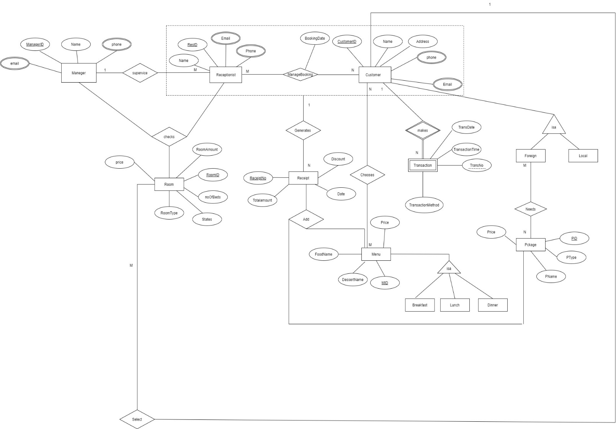

Breakfast, Lunch and Dinner covers menu and disjoint.

Foreign and Local covers the customer and disjoint.

**03.**

**a. b.**

* Manager (ManagerID, Name)
* Manager_Phone (ManagerID, Phone)

Foreign key (ManagerID) references Manager (ManagerID)

* Manager_Email (ManagerID, Email)

Foreign key (ManagerID) references Manager (ManagerID)

* Receptionist (ResID, Name, ManagerID)

Foreign key (ManagerID) references Manager (ManagerID)

* Receptionist_Phone (ResID, Phone)

Foreign key (ResID) references Receptionist (ResID)

* Receptionist_Email (ResID, Email)

Foreign key (ResID) references Receptionist (ResID)

* ManageBooking (ResID, CusId, BookingDate)

Foreign key (ResID) references Receptionist (ResID)

Foreign key (CusID) references Customer (CusID)

* Customer (CusID, Name, Address)
* Local (CusID)

Foreign key (CusID) references Customer (CusID)

* Foreign (CusID)

Foreign key (CusID) references Customer (CusID)

* Package (PID, PName, PType, Price)
* Needs (CusID, PID)

Foreign key (CusID) references Customer (CusID)

Foreign key (PID) references Package (PID)

* Customer_Phone (CusID, Phone)

Foreign key (CusID) references Customer (CusID)

* Customer_Email (CusID, Email)

Foreign key (CusID) references Customer (CusID)

* Transaction (CusID, TransNo, TransactionMethod, TransactionTime, TransDate)

Foreign key (CusID) references Customer (CusID)

* Receipt (ReceiptNo, TotalAmount, Date, Discount, CusID, ResID)

Foreign key (CusID, ResID) references ManageBooking (CusID, ResID)

* Room (RoomID, noOfBeds, RoomAmount, Price, Type, CusID)

Foreign key (CusID) references Customer (CusID)

* Checks (ManagerID, ResID, RoomID)

Foreign key (ManagerID) references Manager (ManagerID)

Foreign key (ResID) references Receptionist (ResID)

Foreign key (RoomID) references Room (RoomID)

* Menu (MID, Price, FoodName, DessertName, Type)
* Chooses (CusID, MID)

Foreign key (CusID) references Customer (CusID)

Foreign key (MID) references menu (MID)

* Add (MID, PID, RecieptNo)

Foreign key (MID) references Menu (MID)

Foreign key (PID) references Package (PID)

Foreign key (ReceiptNo) references Receipt (ReceiptNo)

**c. 1.**

Option 1 mapping is used to map customer. Because sub classes have their own relationship also disjoint and cover constraint there. Parent entity also has relationship. Then the best mapping is option 1.

2. Option 3 mapping is used to map menu. Because sub classes are not having their own relationship. Also disjoint cover constraint there. Then the best mapping is option 3.

**4)**

**a.**

Select f.CustomerID , f.Name , count(p.PID)  
From Foreign f , Package p , Needs n  
Where f.CustomerID = n.CustomerID and p.PID= n.PID and ( p.Price > 100000 and p.PType = ‘Full’)  
Group by p.Pname  
Having count(p.PID) > 2

**b.**

Select c.CustomerID , f.Name  
From Customer c , Transaction t  
Where c.CustomerID = t.CustomerID and (t.TransactionMethod in (select TransactionMethod from Transaction where  
TransactionMethod = ‘Paypal’)  
and t.TransDate in (‘2021-04-20’,’2021-04-30’) )

**5)**

DELIMITER //

CREATE PROCEDURE AvailableRoomCheck(

IN RoomType VARCHAR(8),

OUT RoomCount VARCHAR(10)

BEGIN

DECLARE totalCount INT;

SELECT COUNT(RoomID) INTO totalCount FROM Rooms

WHERE roomType = RoomType AND status = ‘available’;

SET RoomCount = totalCount;

END //

**6)**

DELIMITER //

CREATE TRIGGER DiscountCal

AFTER INSERT ON Receipt

FOR EACH ROW

BEGIN

DECLARE amount DOUBLE;

SELECT Totalamount INTO amount

FROM Receipt where ReceiptNo = NEW.ReceiptNo;

IF(amount > 50000.00)

UPDATE Receipt SET Discount = 0.10 WHERE ReceiptNO = NEW.ReceiptNo;

ELSEIF(amount > 10000.00 AND amount < 50000.00 )

UPDATE Receipt SET Discount = 0.05 WHERE ReceiptNO = NEW.ReceiptNo;

END IF

END //